**Project Design Phase-II**

**Journey Maps**

|  |  |  |  |
| --- | --- | --- | --- |
| Date | 08/10/2022 | | |
| Team ID | PNT2022TMID23263 |  |  |
|  |
| Project Name | Analytics For Hospitals' Health-Care  Data | | |

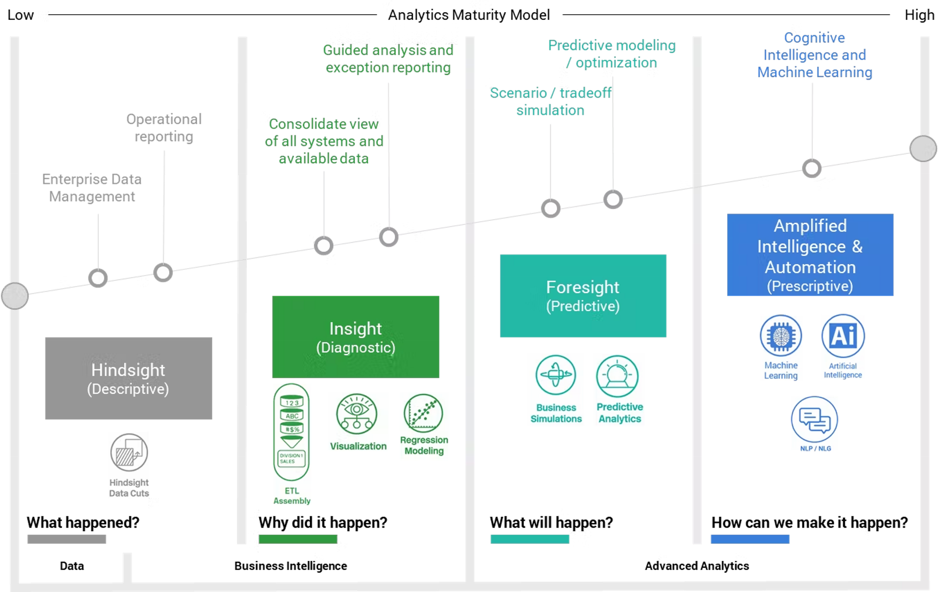

**User Journey Maps**

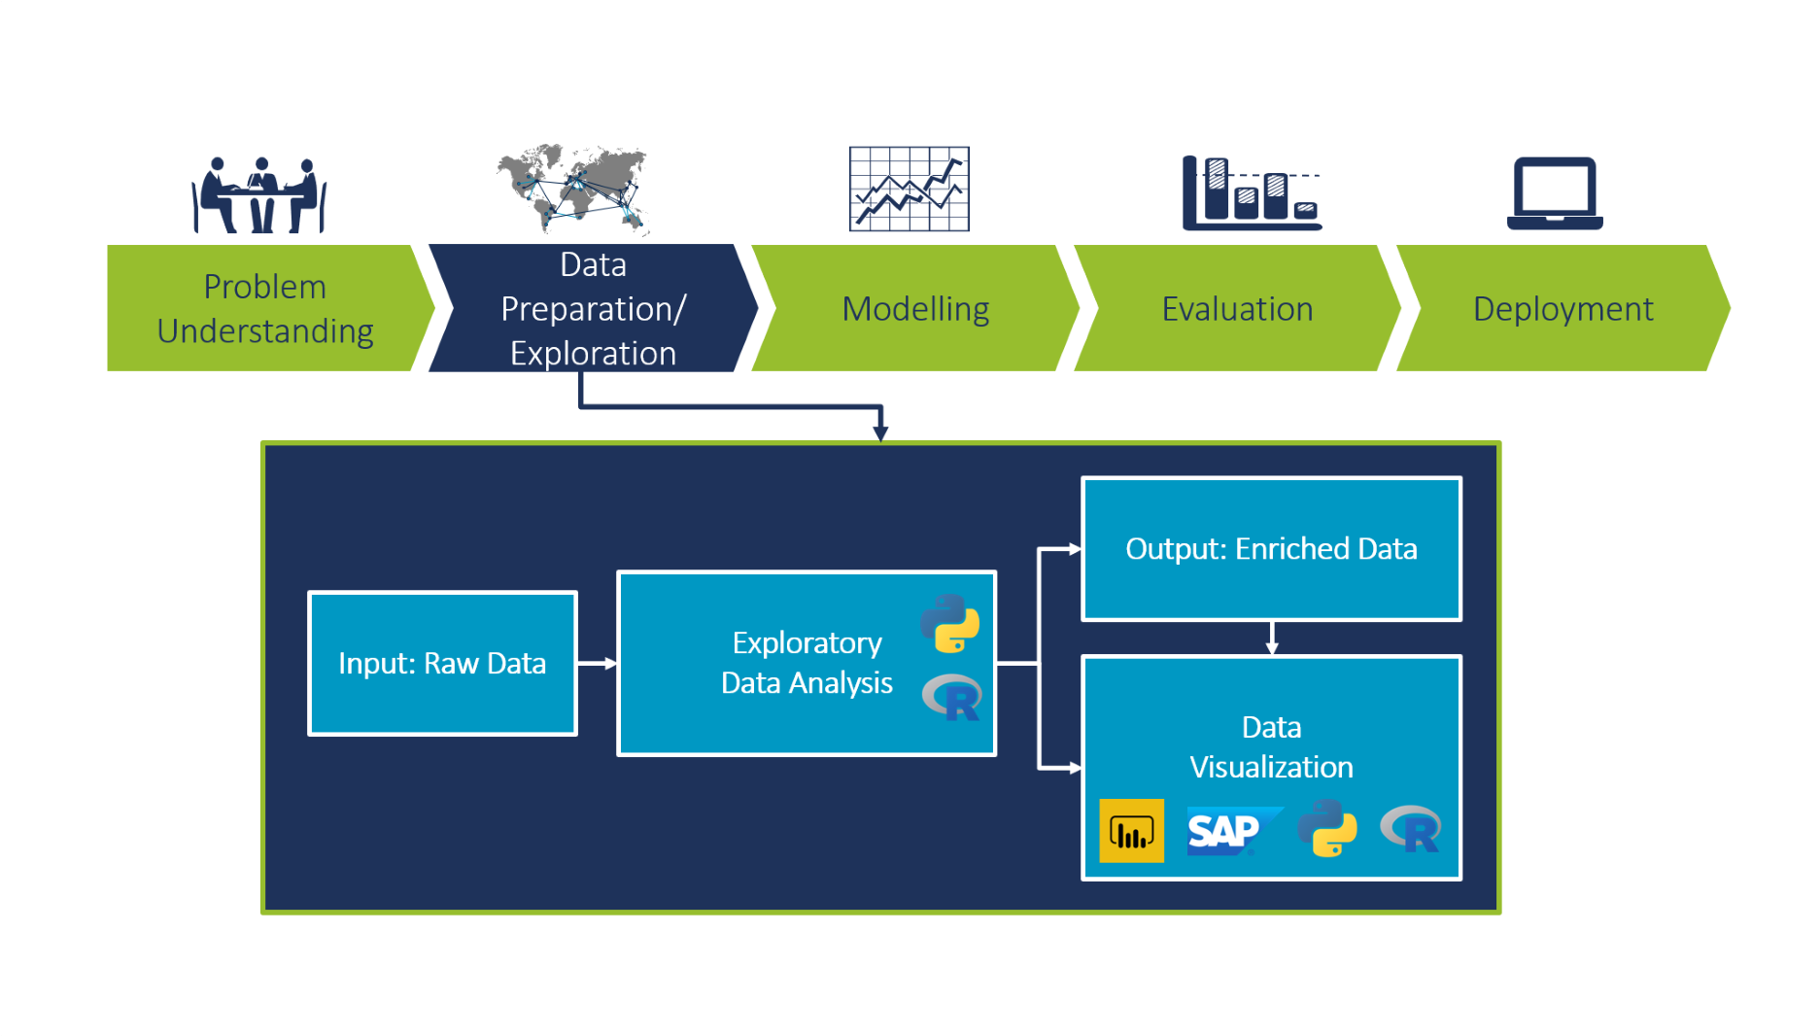

**Data Flow Daigram**